**LA DOLCE VITA DELIGHTS**

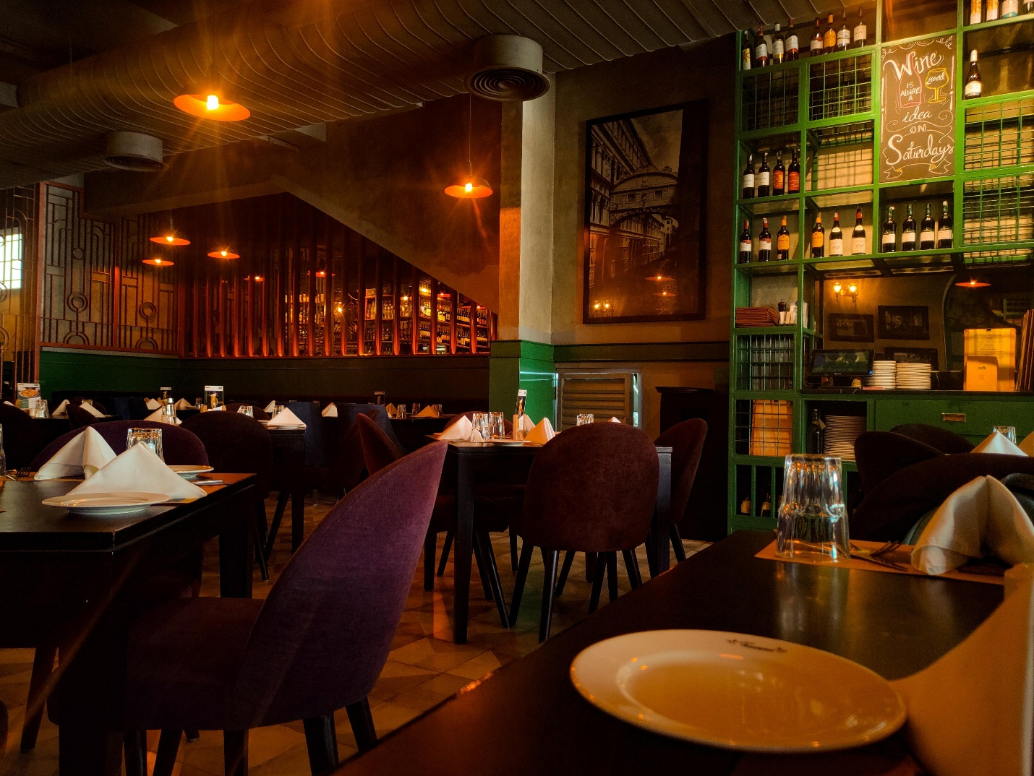

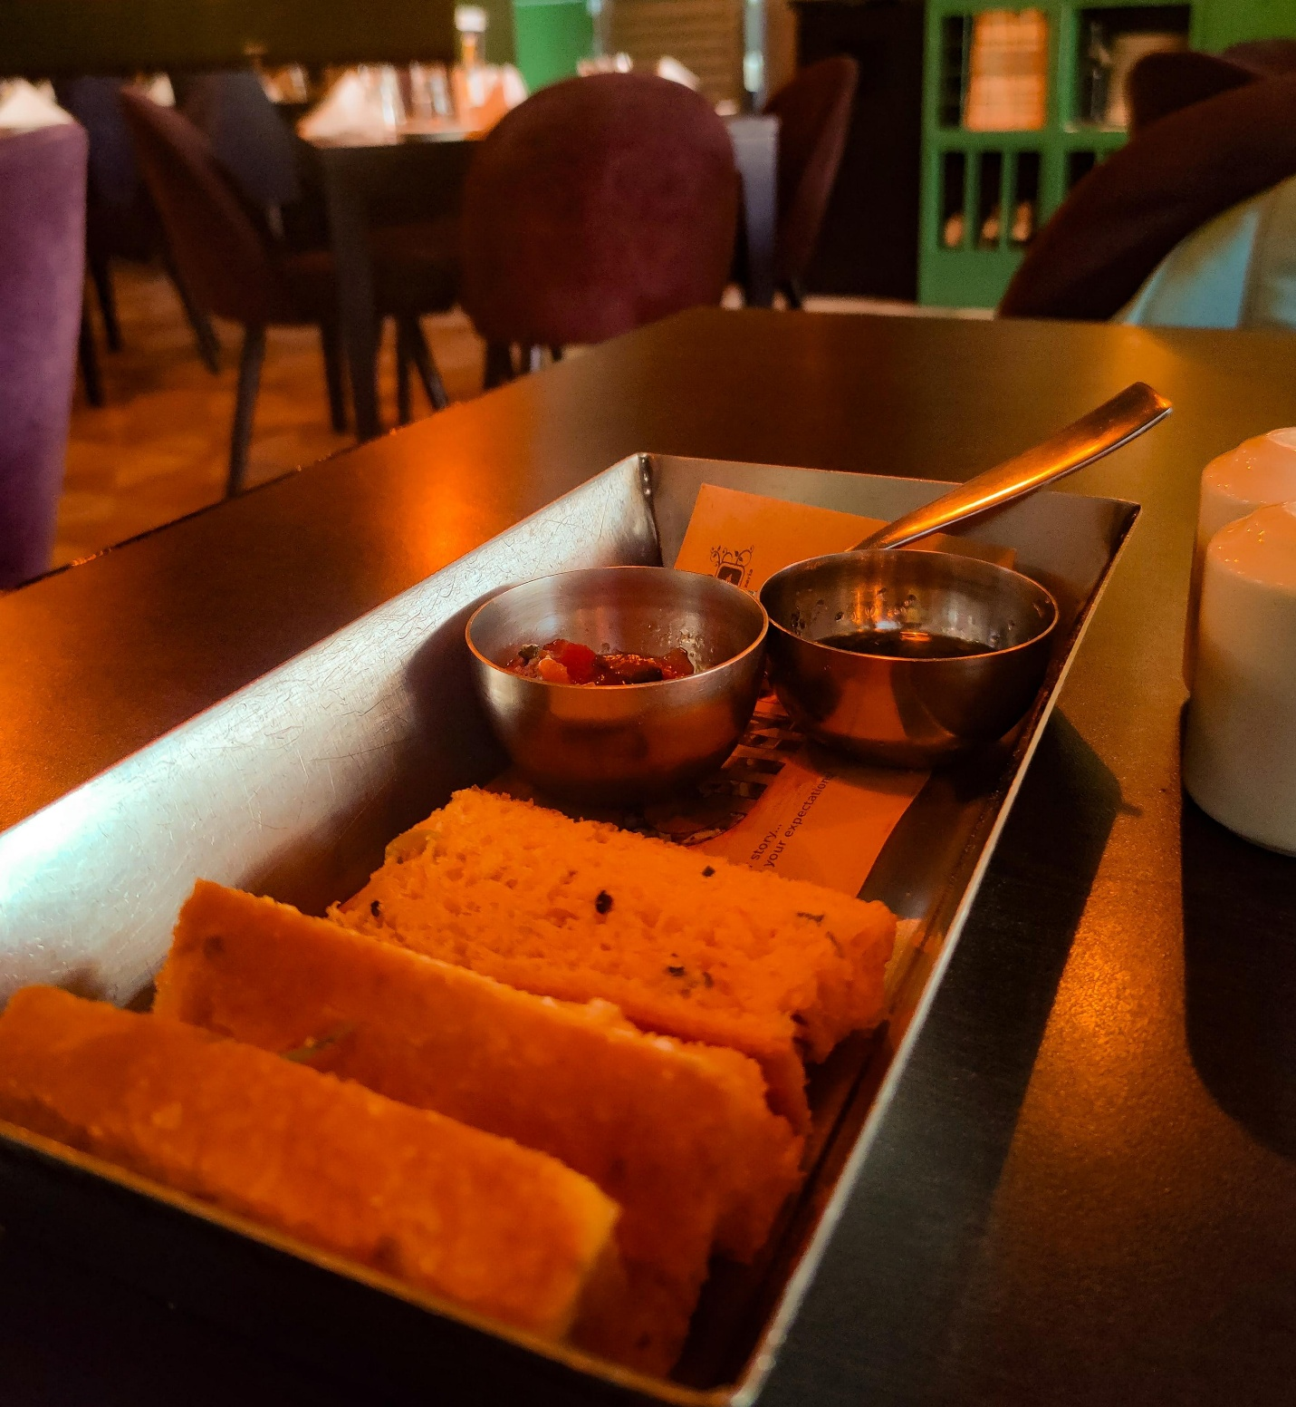

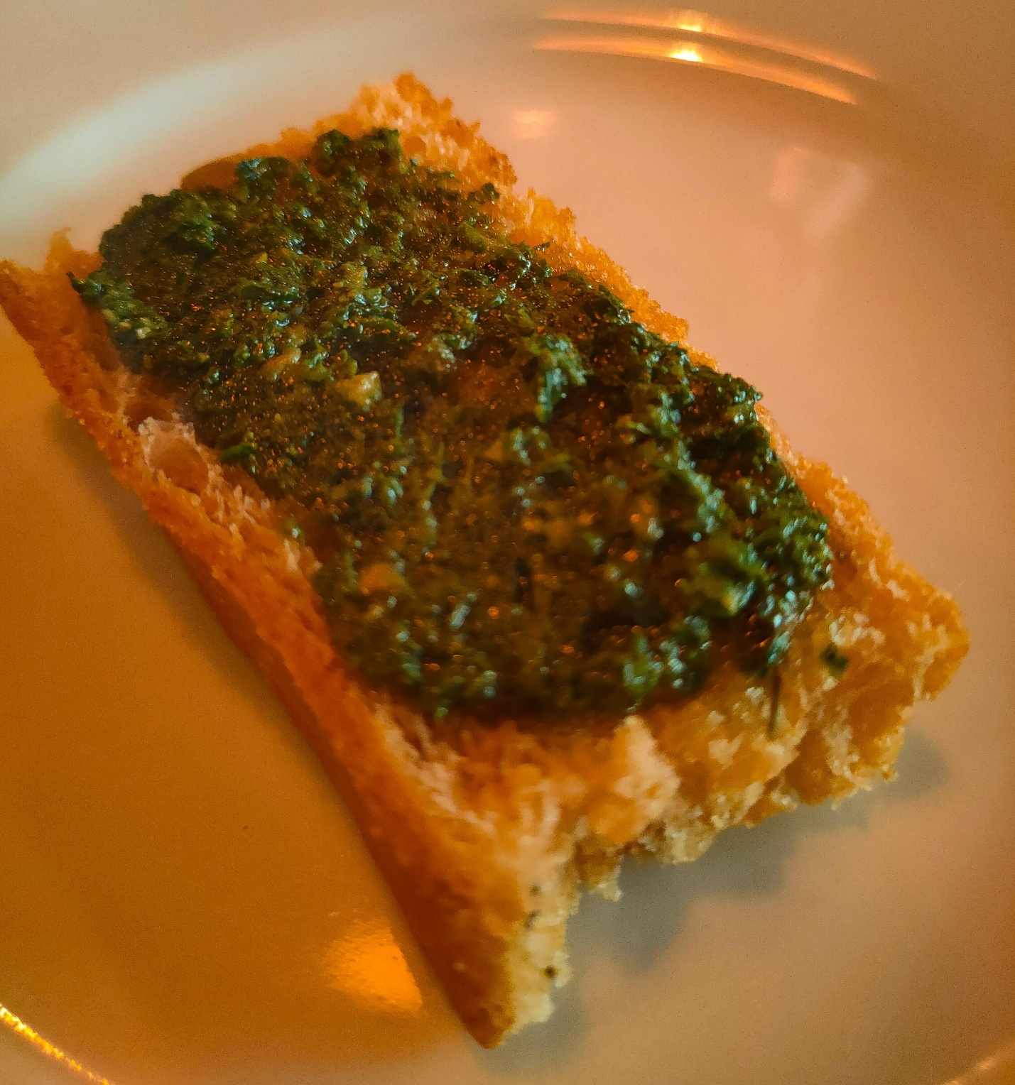

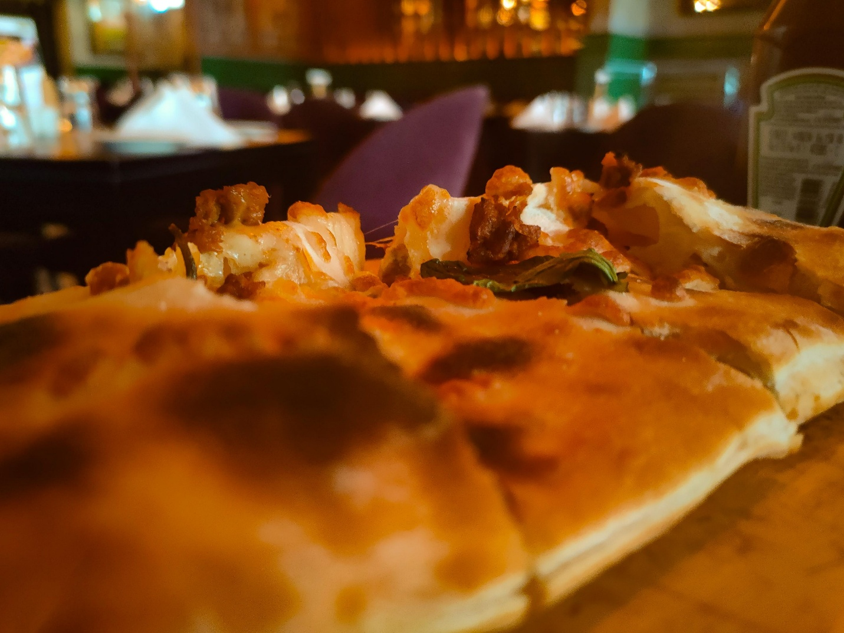

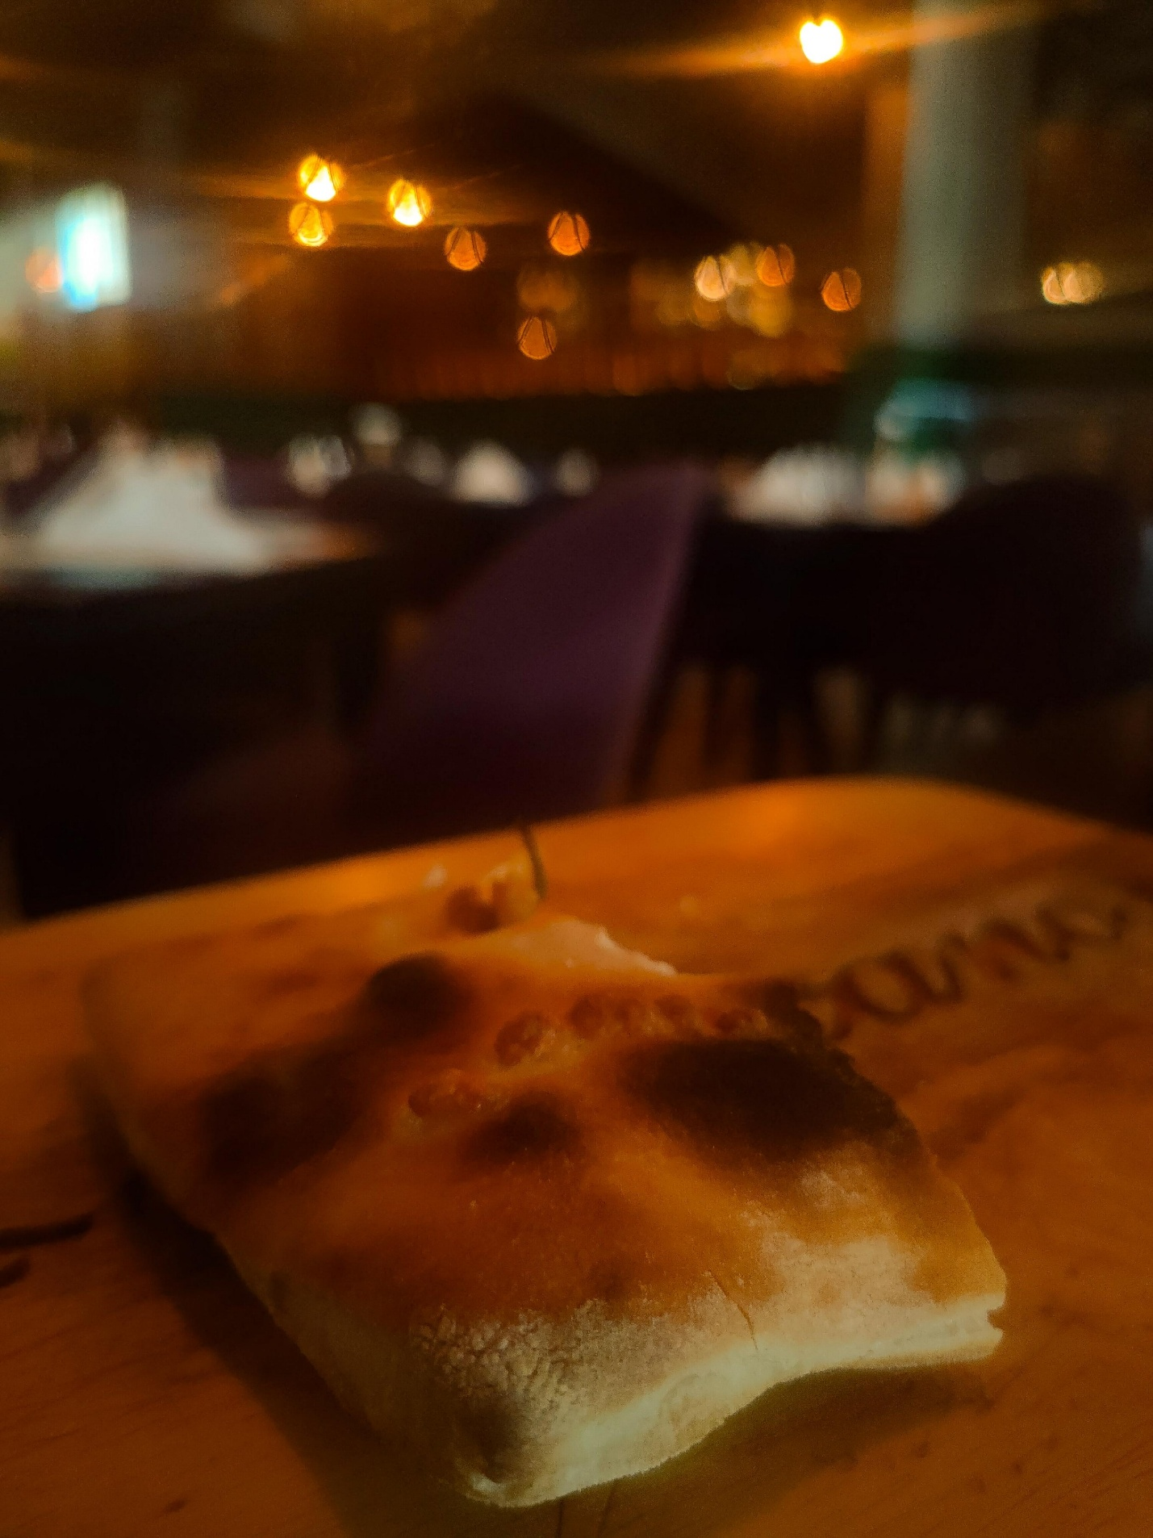

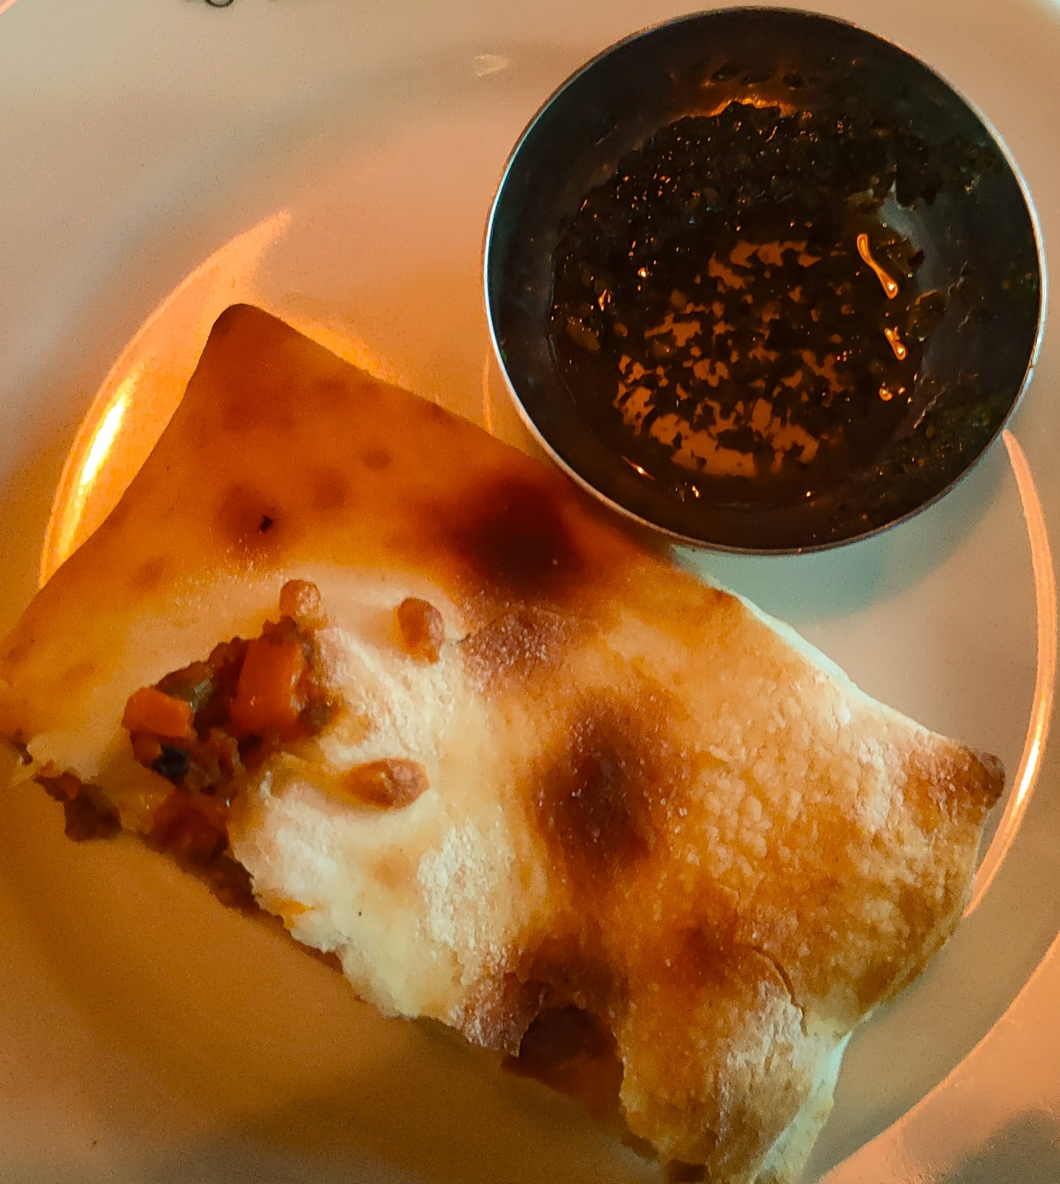

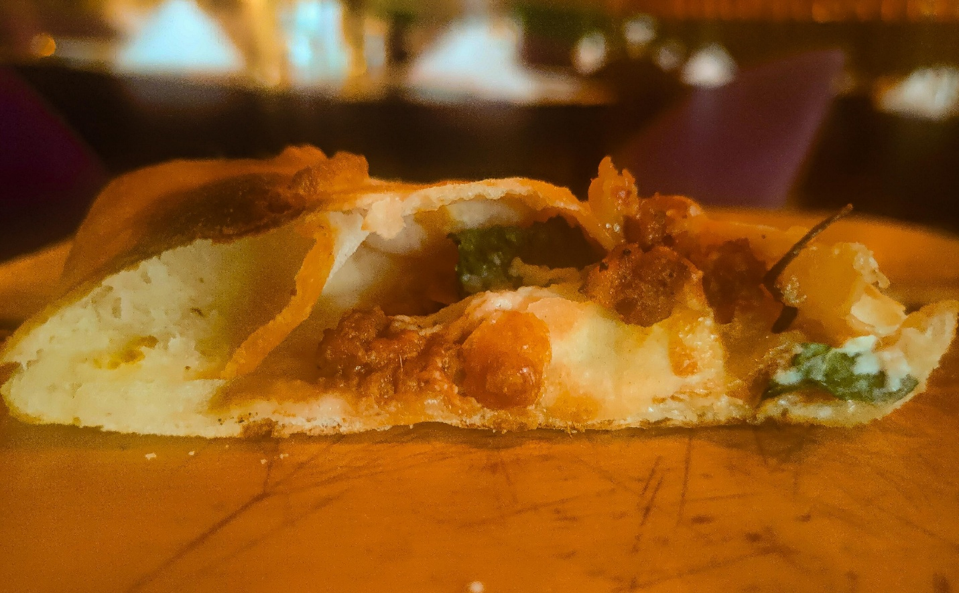

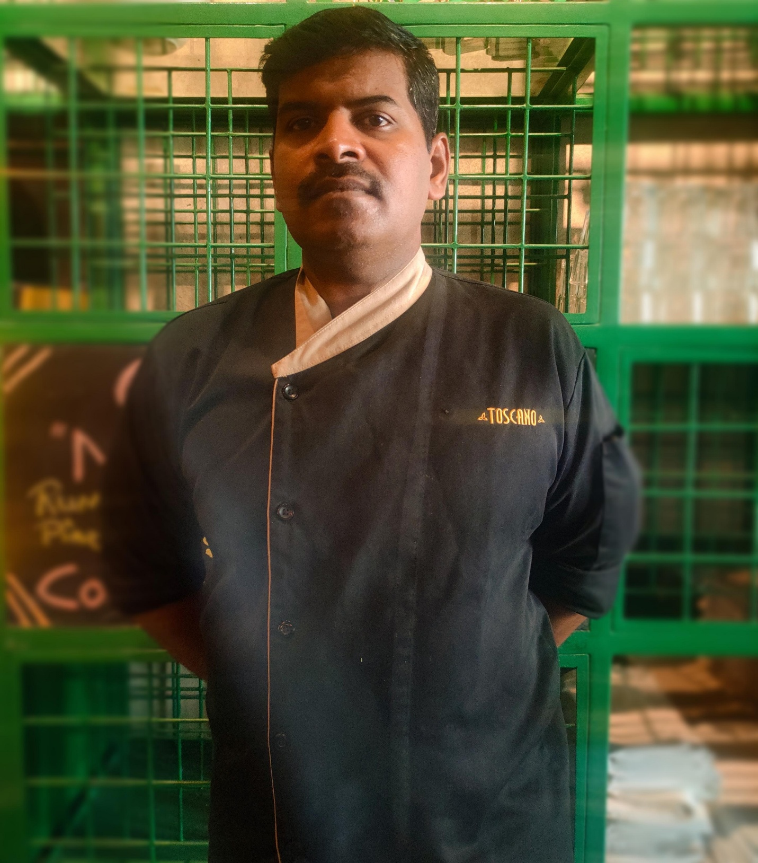

On the 8th of February I visited this rustic Tuscan-inspired restaurant at KNK called Toscano. I spent the delightful evening sipping on a glass of wine, caught by Italy's illusion and danced with echoes of Tuscan delight. The restaurant wasn't just italian - themed, they genuinely served delicious and authentic italian food that made me feel like I was in Italy. And I decided to order Italy's favourite food bruschetta, it was 'da leccarsi i baffi' good, made with rustic italian baguette bread, brushed with olive oil and rubbed with garlic cloves to enhance the flavour and served diced cherry tomatoes topping and freshly chopped basil leaves sauce alongside. Since i enjoyed my first meal, i took a stab at ordering another dish it's called

mediterranean-inspired minced lamb and goat cheese garlic bread made with focaccia bread infused with minced lamb, goat cheese for a creamy and tangy flavour, minced garlic to give an authentic flavour of garlic bread, sautéed onions and cherry tomatoes along with herbs like thyme, rosemary and tossed in handful of mint for extra freshness. Overall the food tasted delizioso and lo chef ha fatto un ottimo lavoro hence i decided to meet the chef. Chef Sugan, the man behind the exquisite and meticulously crafted italian creations at toscano, chennai. Chef Sugan embarked on a transformative journey by pursuing his culinary studies overseas, his dedication to mastering the culinary arts beyond borders has turned him into a culinary ambassador, creating unforgettable dining experiences that resonate with a world of flavours. To sum up, i personally found the food scrumptious and loved the ambiance of the restaurant also highly recommend you to give it a taste.